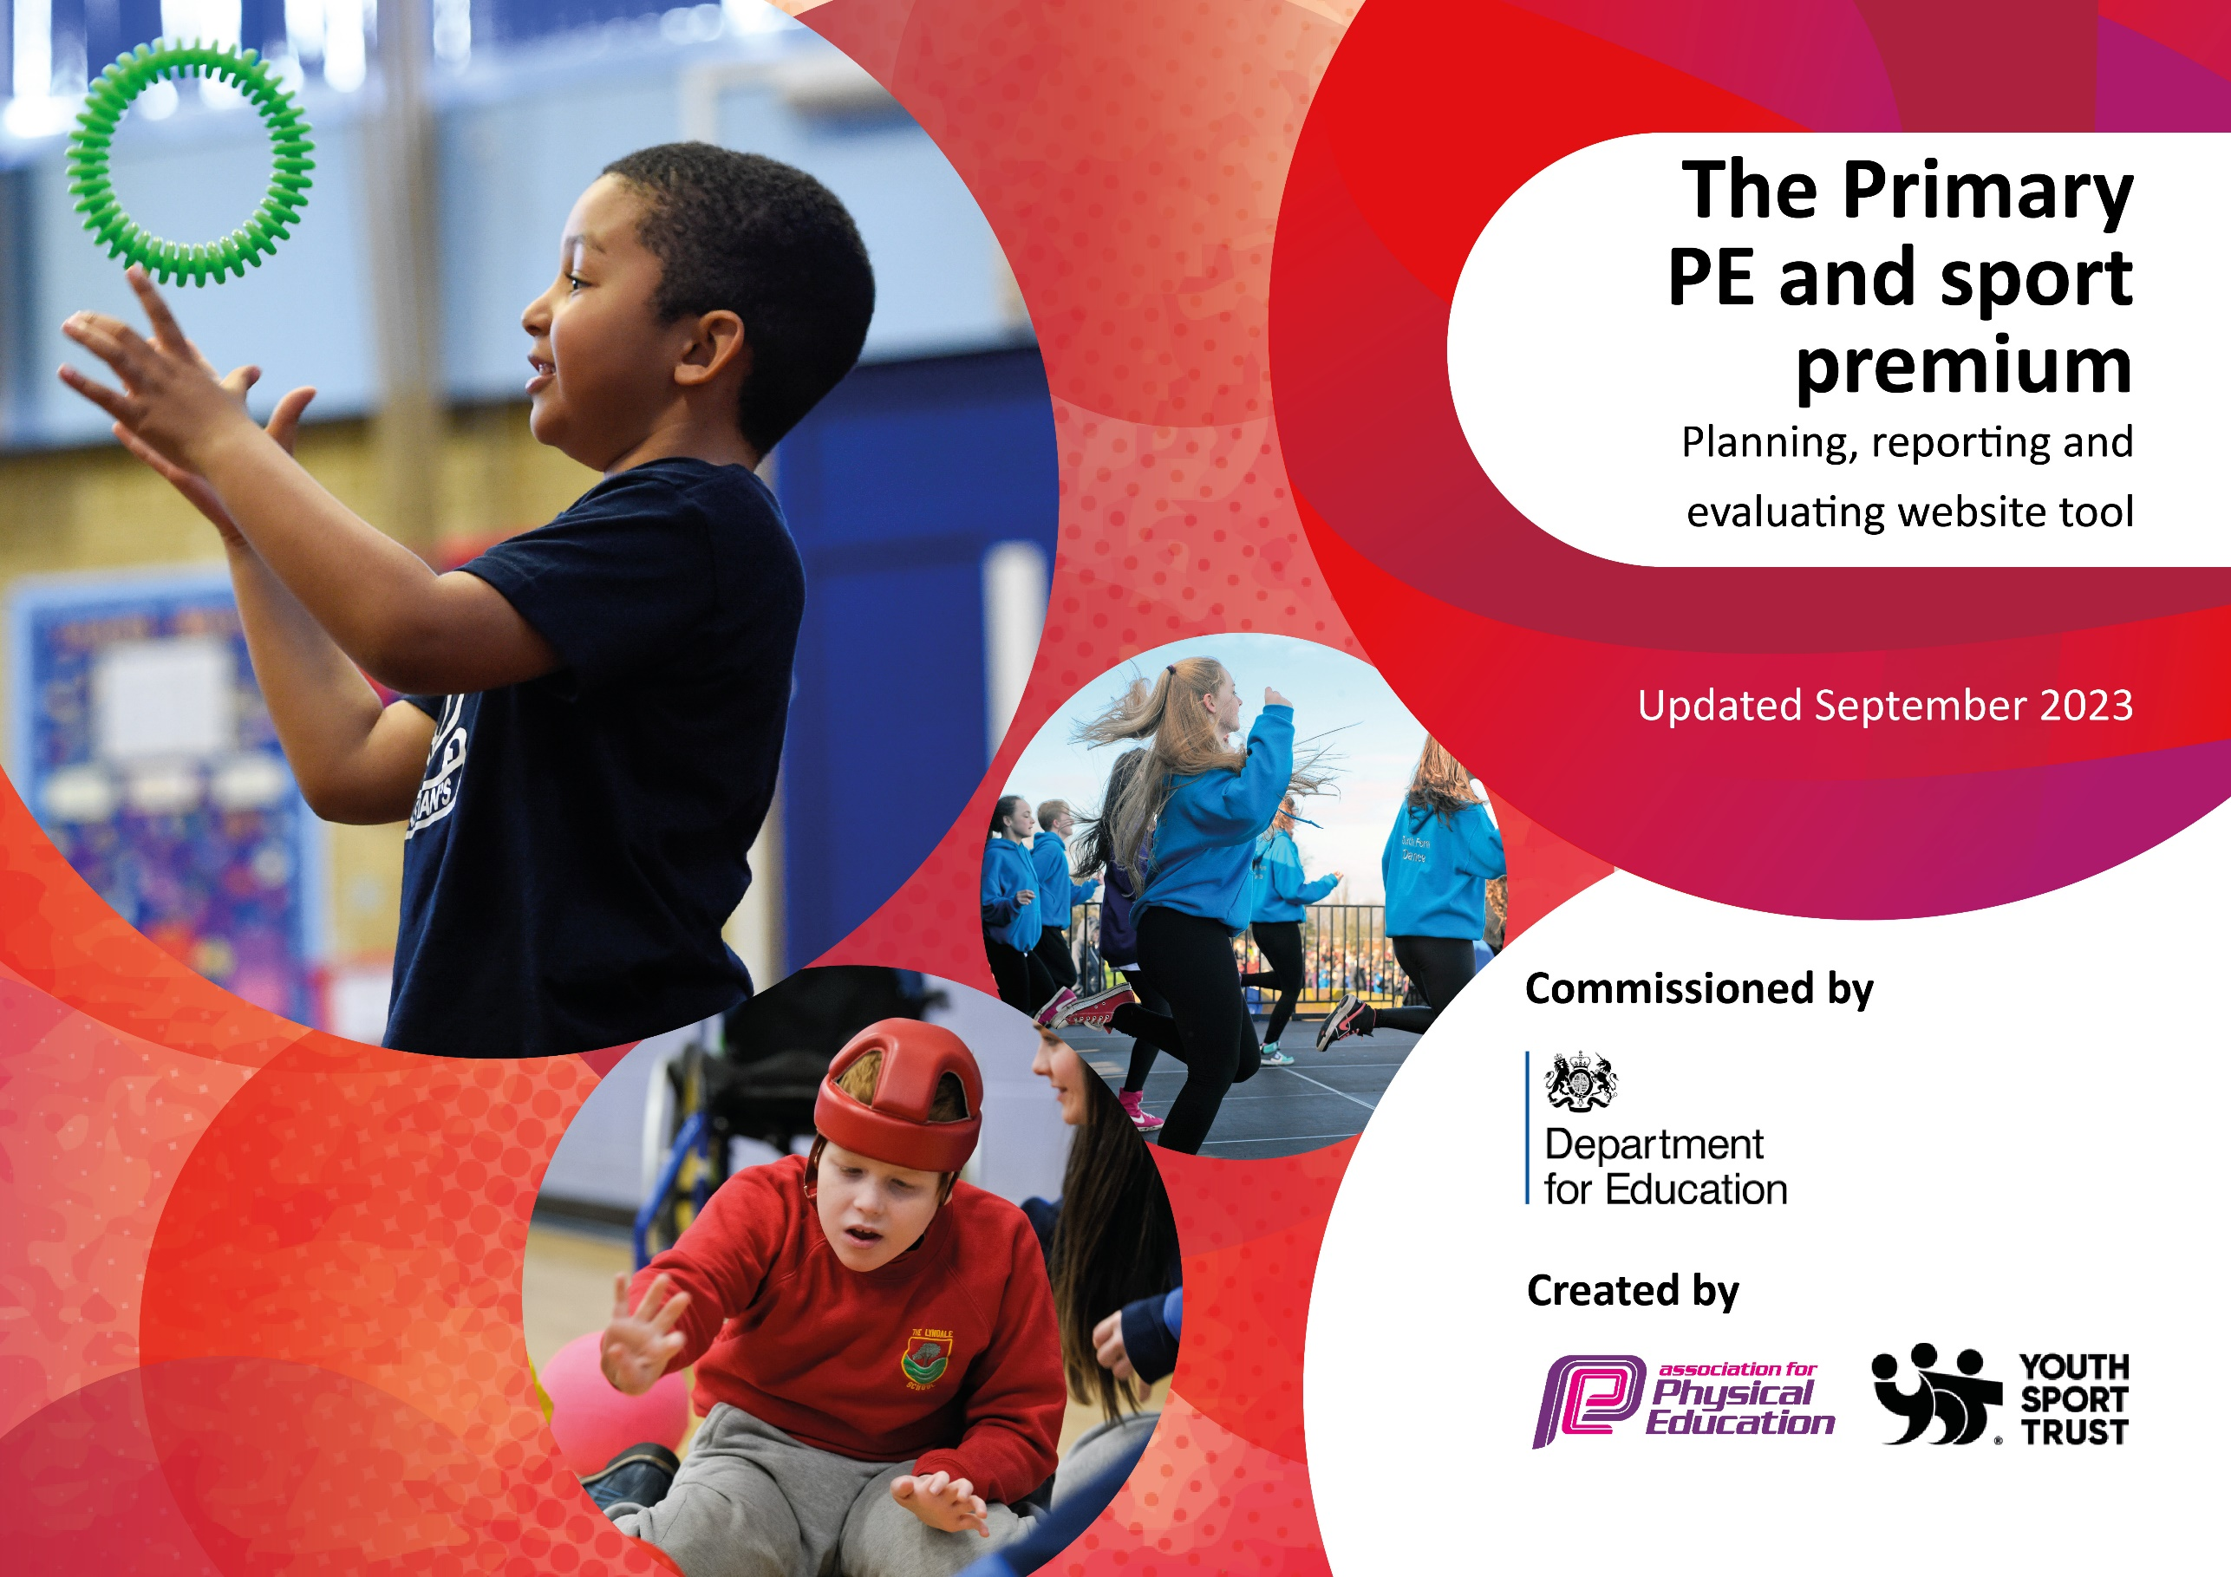

Wilton Primary Academy

Although completing this template is not a requirement for schools, schools are required to publish details of how they spend this funding. Schools must also outline what the impact this funding has had on pupils’ PE and sport participation and attainment and how any spending will be sustainable in the future. All funding must be spent by 31st July 2024.

The Department for Education has worked closely with the Association for Physical Education (afPE) and the Youth Sport Trust (YST) to develop this template and encourages schools to use it. This template is an effective way of meeting the reporting requirements of the Primary PE and sport premium.
Review of spend and key achievements (2023/2024) Spend £17706

We recommend you start by reflecting on the impact of current provision and reviewing your previous spend.

Activity/Action | Impact | Comments
RESSP membership (£5000)  Competitions (£2976)  RESSP UKS2 Tag Rugby Event - transport  RESSP KS1 Dance/Gymnastics Event - transport  RESSP EYFS Balance Festival - transport  RESSP LKS2 Netball Development Day - transport  Tree-tops  (£2310)  Catch-up swimming  (£900)  School PE Kits  (£1500)  Sports Equipment  (£5020)  Balance Bikes/Bikeability  Pedestrian training | CPD for staff, whole school PE activities, competitions, development days, Complete PE discounted membership.  Several children then joined external rugby clubs.  Enabled a new child to the area to mix and settle faster.  Year 1 / 2 children encouraged to work within a team.  Balance and special awareness improved.  Reception and Nursery children improving coordination and balance skills.  Year 3 / 4 learning to work within a team and how to follow the rules of a sport.  Motor development assessment and specific programme for 2 children.  All UKS2 able to swim the 25m statutory length.  All children have a PE kit in school and are able to participate in PE lessons.  Teachers are able to effectively deliver lessons using the correct equipment.  Children prepared for learning to ride a bike safely and on the roads.  Children understand how to keep themselves safe near roads. | Very supportive and eager to share their knowledge.  All children enjoyed the afternoon and were actively engaged in a physical activity. Tag belts out side over lunchtime have increased additional activity and engagement.  Children more aware of personal space and refined motor skills.  Great activity for all the children to improve their skills. More children have bikes at home as a result.  Children enjoyed the challenge and worked well in teams.  Daily motor programme impacts positively on co-ordination and motor skills.  This enabled us to achieve 100% at 25m  Children no longer have to bring in kits and all children have equity over being able to participate in lessons.

Swimming Data
Meeting National Curriculum requirements for swimming and water safety.
Priority should always be given to ensuring that pupils can perform safe self-rescue even if they do not fully meet the first two requirements of the National Curriculum programme of study

Question | Stats: | Further context  Relative to local challenges
What percentage of your current Year 6 cohort can swim competently, confidently and proficiently over a distance of at least 25 metres? | 100% | This was following 2 children attending the catch-up sessions.
What percentage of your current Year 6 cohort can use a range of strokes effectively [for example, front crawl, backstroke, and breaststroke]? | 60% | This was following 2 children attending the catch-up sessions.

What percentage of your current Year 6 cohort are able to perform safe self-rescue in different water-based situations? | 60%
If your schools swimming data is below national expectation, you can choose to use the Primary PE and sport premium to provide additional top-up sessions for those pupils that did not meet National Curriculum  requirements after the completion of core lessons. Have you done this? | Yes/No
Have you provided CPD to improve the knowledge and confidence of staff to be able to teach swimming and water safety? | Yes/No | Our swimming lessons (including water safety) are delivered by qualified swimming instructors at the swimming pool.

Signed off by:

Head Teacher: | Sara Hood
Subject Leader or the individual responsible for the Primary PE and sport premium: | Stephanie Harding
Governor: | (Name and Role)
Date: | 18/7/24

