Autumn Newsletter

Where have the last eight weeks gone? Thank you for all the support you have given over the last half term. I hope you all have an enjoyable half term and return safely on the 4th November.

Staffing
We are saying bye to Mrs McGarrity on Friday. She is transferring to Dormanstown Primary to support with the development of their Early Years. As a result, Miss Ferguson will be working in Early Years on a morning and KS1 on an afternoon. As you will know, Miss Fitzgerald started her maternity leave earlier in October, Miss Harland is covering her absence, which starts after the holidays.

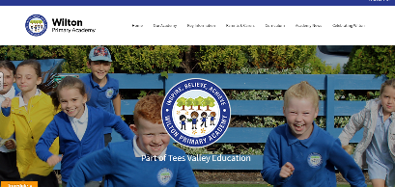
Website
In September, the academies new website was launched. The website is a more user friendly site on which we will post photos and information about events that have taken place. Here is the link to the website - http://wilton.teesvalleyeducation.co.uk/.

Academy Parliament
We are Phoebe, Jay, Dylan and Cara and we are the academy parliament. Our job is to make sure that the people in our class get to give their opinions and help to improve the academy. We have been on a learning walk and noticed that most of the children in our academy follow the rules and try their best. Our teachers have worked to make sure our classrooms are bright and colourful and when we work the classrooms are mainly calm. Presentation in books is better than expected. All the teachers are kind and make sure the children are safe.

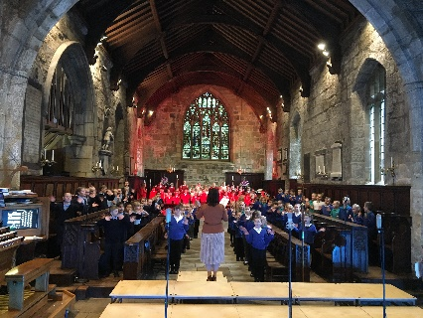
Trips and Visits
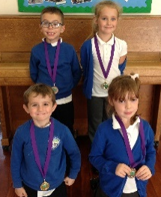
Our fabulous team of KS1 runners took part in the TVE Cross Country Trophy at Pennyman Primary earlier this month and did exceptionally well. A team of Y6 artists visited MIMA this week and learnt a host of new skills which they will be putting into action in the next half term to teach the rest of the academy. Yesterday, the choir performed beautifully at St Nicholas Church in Guisborough at the Choir Festival.

Parents Evening
It was lovely to see so many of you on both parents evenings this week, the support you give us really helps us to continue to make the progress in the academy. If you were unable to attend, please contact the office on 01642 453374 to arrange an alternative date.

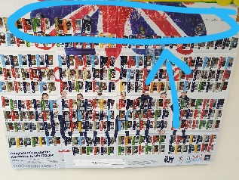
Aldi Kit for Schools
We are so close to completing the sticker chart, something I never thought was possible when we started, so thank you for your help with this. If you are shopping in Aldi over the holidays please ask for your stickers. Any ideas of a project we could do with the potential winning prize would be gladly received.

MacMillan Coffee Morning
I am delighted to say we raised an incredible £184.55 at the coffee morning. Thank you so much for the support you gave to this. As an academy, we have set ourselves a target of supporting charities and events during the course of the year with the hope of raising £1000 in total. Look out for future events linked to Children in Need and Christmas Jumper Day.
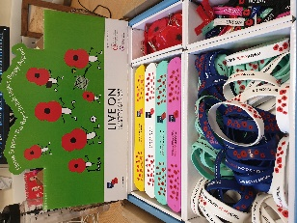
British Legion – Remembrance Day
During the first week back we will be selling items on behalf of the Royal British Legion, supporting veterans. The items we have for sale include snap bands, wristbands and poppy reflectors which range from 50p to £1.50. Poppies are also on sale for a donation.

Expectations
As an academy, we expect high standards of behaviour at all times. Since introducing the new system, we have seen a huge improvement in the general behaviours around the academy. We would really appreciate your support in this area, encouraging the children to be polite and reinforce messages which come from school. As a reward for those children who always behave, we have had a reward afternoon to celebrate consistently excellent behaviours. Further information on the expectations will come out after the holidays.

Arts Council
We are Lacey-Mae, Isla, Holly, Tierney, Luke and Ashlyn and we are working to improve art, music, drama and dance. We are working with a local artist called Bubb. She has been in 5/6 working on sculpture. Three Y6 children went to MIMA to explore drawing, Luke told us that it was a fantastic experience. Watch out for more from us later in the year.

Your opinion matters
I am determined to make Wilton Primary a place where all children in the village want to come. If you have any ideas or suggestions to improve the academy any further, please either send them in or get in touch with the office.

