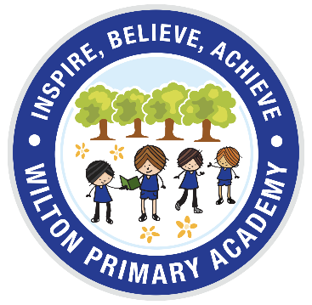
Wilton Primary Academy
Home Learning

This home learning is for this week. While this is not compulsory, children are encouraged to complete the tasks on a weekly basis.
Please email pictures of learning to RWPEYFSWilton@tved.org.uk so we can see what you have been doing we can reply.
In the summer term we would be thinking about preparing the children for full time school. A ‘school ready’ challenge will be set to practise each week. Anything you can do at home to help your child become independent will be a great benefit to them.
‘Please send us your photos. We love seeing what you have been doing!’

Nursery
27.4.20

Subject | Learning Challenge
Maths | Number of the week ‘2’. Watch Numberblocks Series 1 episode 3  https://www.youtube.com/watch?v=xyRFdFSGsgQ  Learn the rhyme ‘Two Little Dickie Birds’. Practise counting to 10.  Go on a hunt for things that come in 2’s (socks, shoes, gloves) or you have 2 of in your home. Talk about which parts of the body we have 2 of and how 2 is one more than 1.  Write the number 2 and learn to recognise the number 2.
Phonics | Please watch the daily Read Write Inc phonics session. Set 1 9.30am. Click link RWI Phonics  The videos are available for 24hrs after being shown. Can you think of words starting with the sounds? Play I spy using the sounds.
Reading | Share a story with your child; this could be one from home, one from Oxford Owl https://home.oxfordowl.co.uk/books/free-ebooks/ or from Teach your Monster to Read. Talk about the story. Can they retell parts of the story?
Writing | Practise writing your name and recognising it. Join in with Dough Disco Dough Disco to strengthen muscles for writing. Playdough pots are available to collect from school.
The World | Go on a minibeast hunt in your garden or when out on a walk. Can you draw a picture of what you have seen and tell me about it? How many different bugs can you find? Remember to email your pictures.
Getting School ready | Practise holding and using a knife, fork and spoon correctly, ready for school lunchtime.
Useful Websites, Programmes and Apps
www.teachyourmonstertoread.com
www.topmarks.co.uk
www.gonoodle.com
www.phonicsplay.co.uk Username: march20 Password:home

Watch episodes of Numberblocks and Alphablocks on Youtube and BBCiplayer
Below are links to online live learning and the times they are being shown each day.

9am | 10am | 11am | General
Joe Wicks PE– 9am  Dough Disco- 9.30am  RWI Phonics  9.30am | Music with Myleen | David Walliams  Let’s go live Science  Body Beats Percussion | Dancing with Oti  Art Ninja  Disney Workouts

Keep an eye on the Academy Facebook and Website for updates and more challenges!

