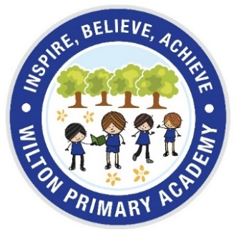
Year 1 & 2 Curriculum
Autumn Term

In Year 1 and 2 this year, we are following the themes of the Year 2 curriculum which will be delivered at a stage appropriate level. The skills and knowledge set out below will be covered in separate subjects as well as cross-curricular lessons. Our cross curricular theme is ‘The Great Fire of London’.

Year 2 | Autumn Term
Maths | Place Value  Addition and subtraction
Reading | Drawing on knowledge of vocabulary to understand texts.  Discuss and clarify the meaning of words
English | Diary Entries  Narratives- adventure stories  Read Write inc for Year 1
Science | Uses of every day materials  Living things and their habitats
History | Significant events locally or nationally:  The Great Fire of London
Geography | Locational geography:  Middlesbrough, the UK and the surrounding seas
PE | Athletics: running  Movement using bounce and body exploration
Art | Artist: Friedensreich Hundertwasser  Techniques: painting, drawing, collage, crayon
DT | Making houses
Music | Weekly singing assembly /Music of the Week  Specialist music provision
PSHE & British Values | Anti-bullying
RE | Christianity and Hinduism
Computing | Hardware and Processing  Algorithms

If you would like any further information regarding our curriculum, please see a member of academy staff, or visit the website.

Mrs Barron

